**Assignment -3**

|  |  |
| --- | --- |
| Student Roll Number | PNT2022TMID03497 |
| Maximum Marks | 2 Marks |

**Question-1:**

# Download the Dataset

**Solution:** from google.colab

import drivedrive.mount('/content/drive')

|  |  |
| --- | --- |
| # | # |
| # | # |

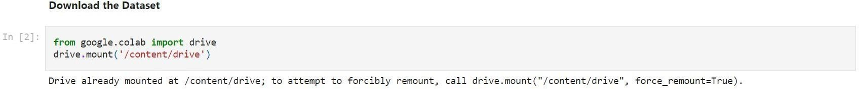

# Question-2: Image Augmentation

Solution :

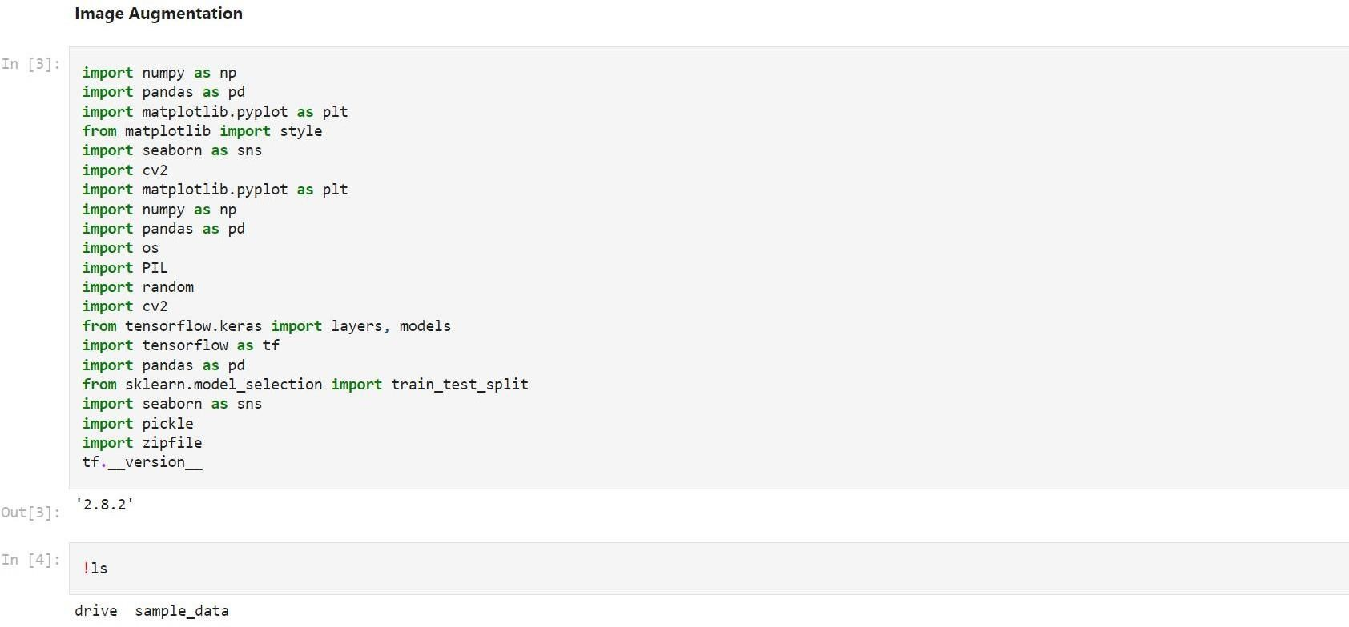

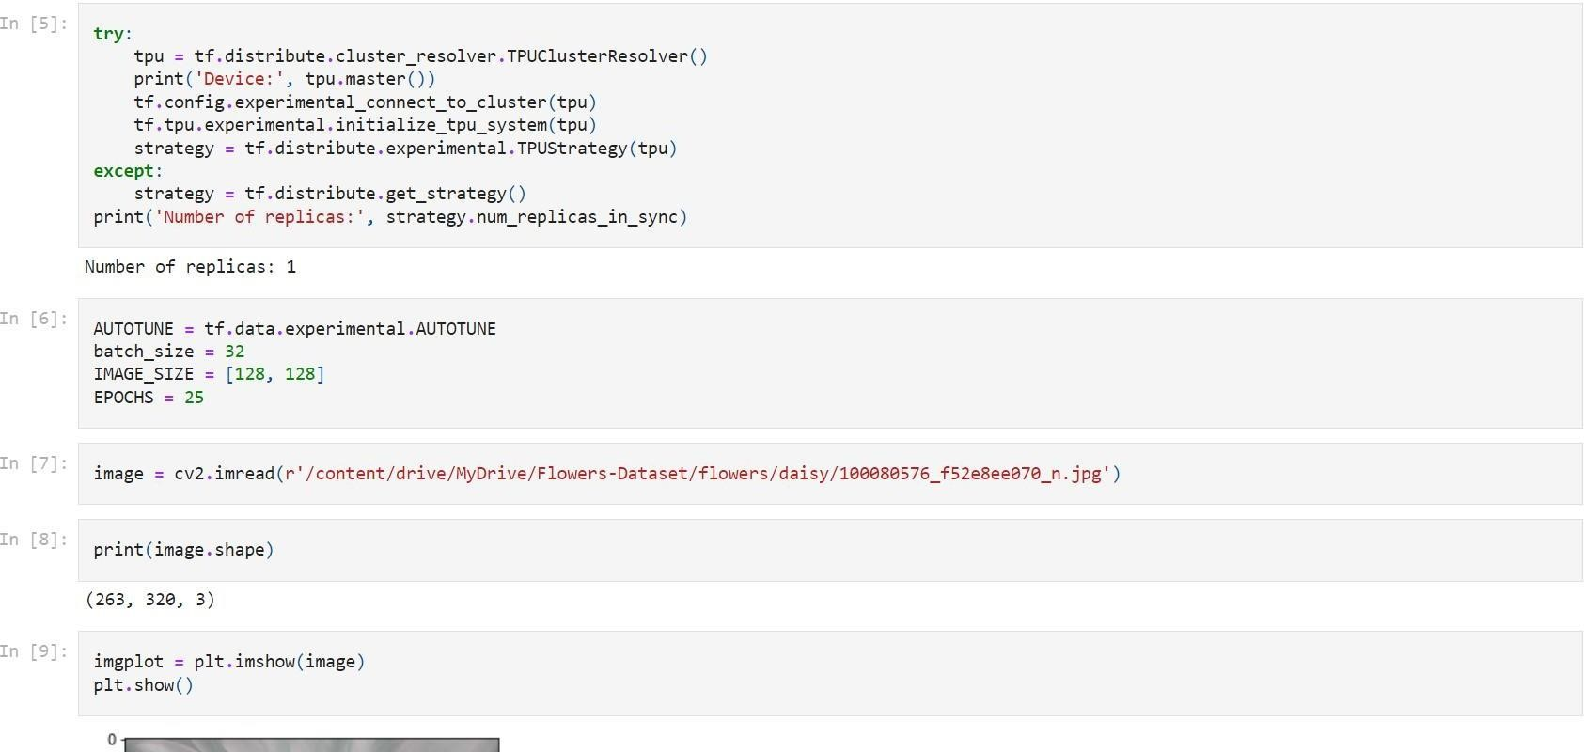

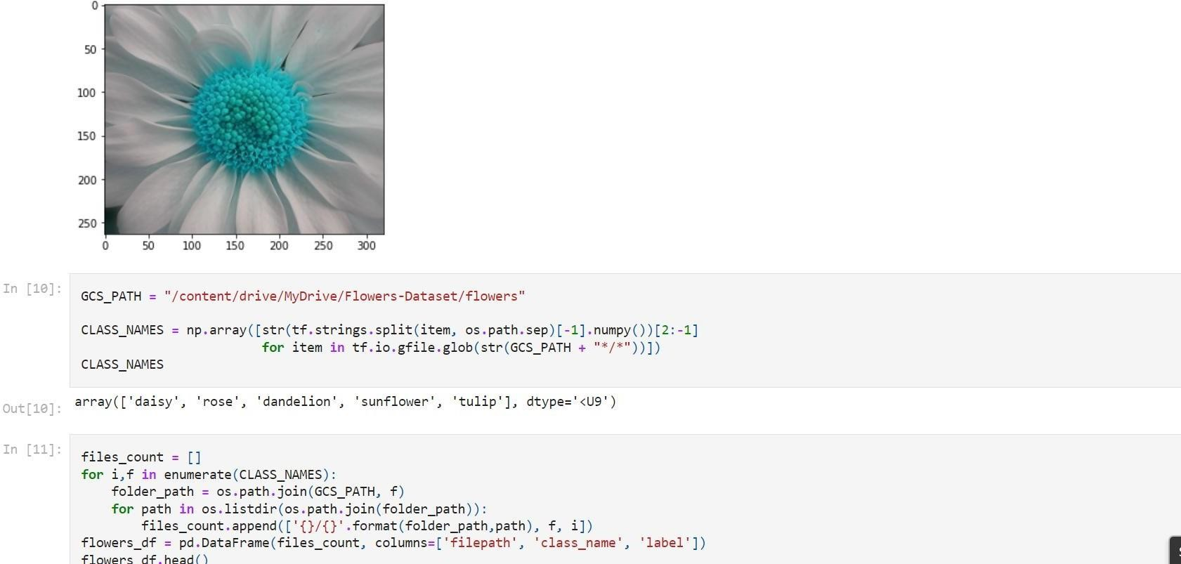

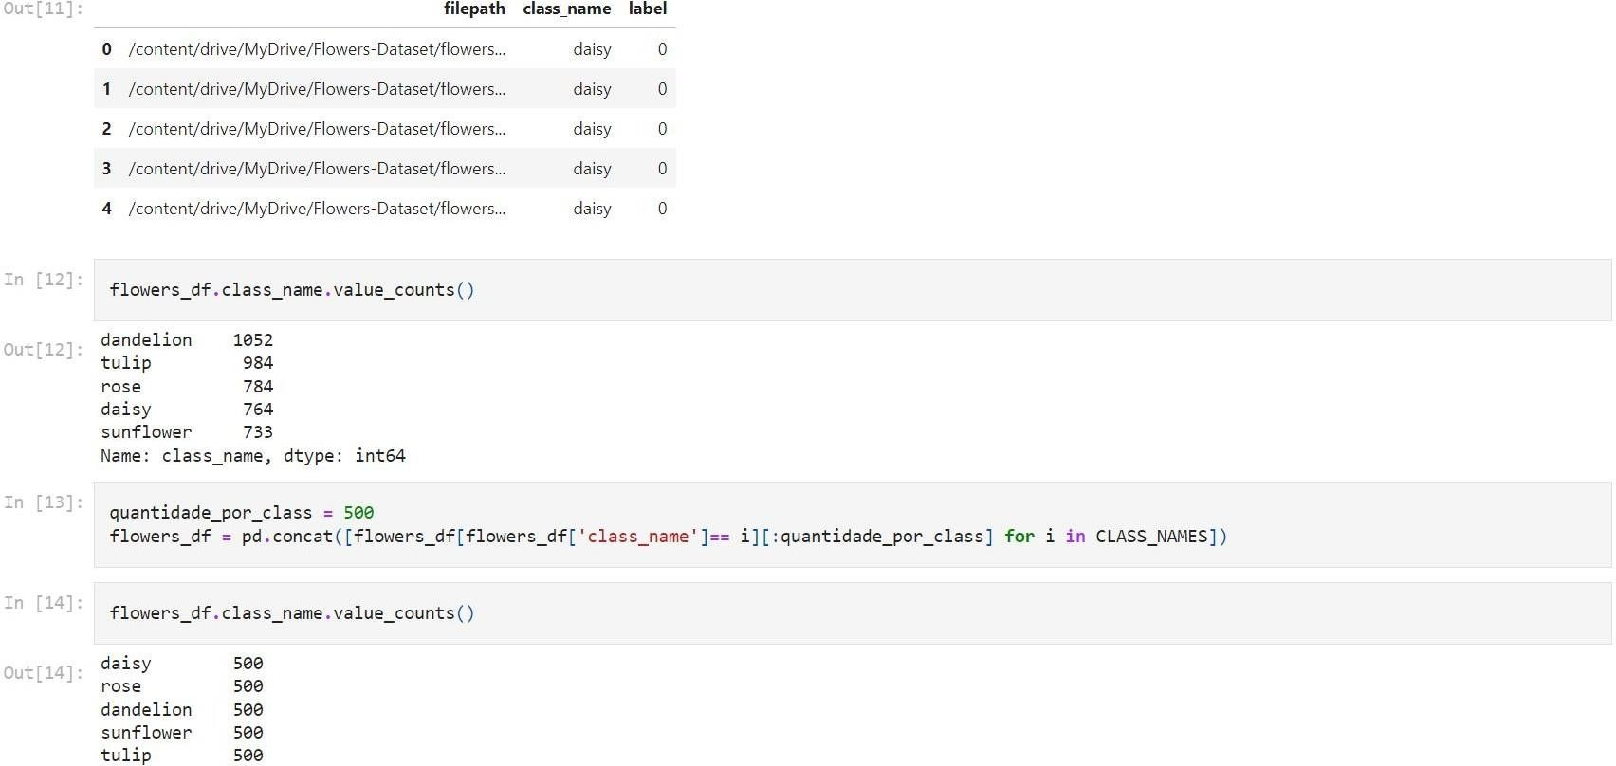

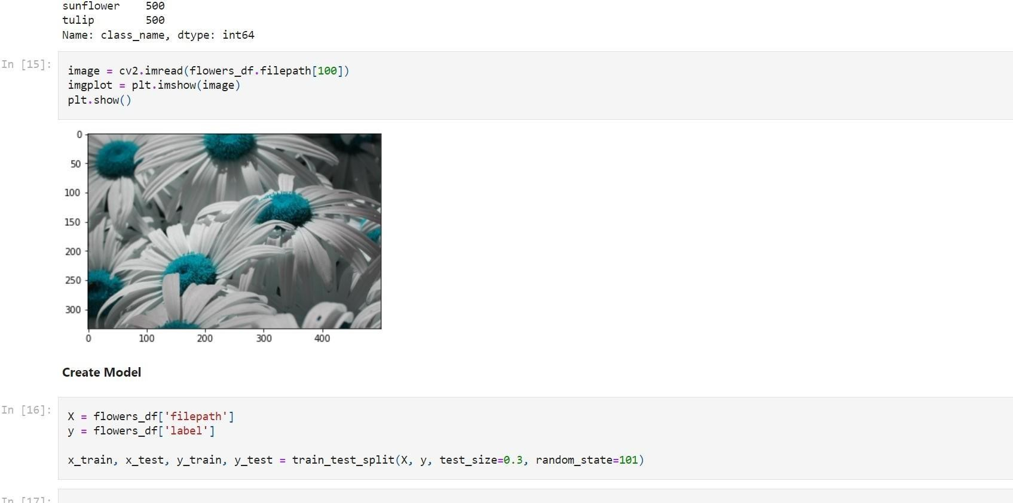

# Question-3: Create Model

Solution :

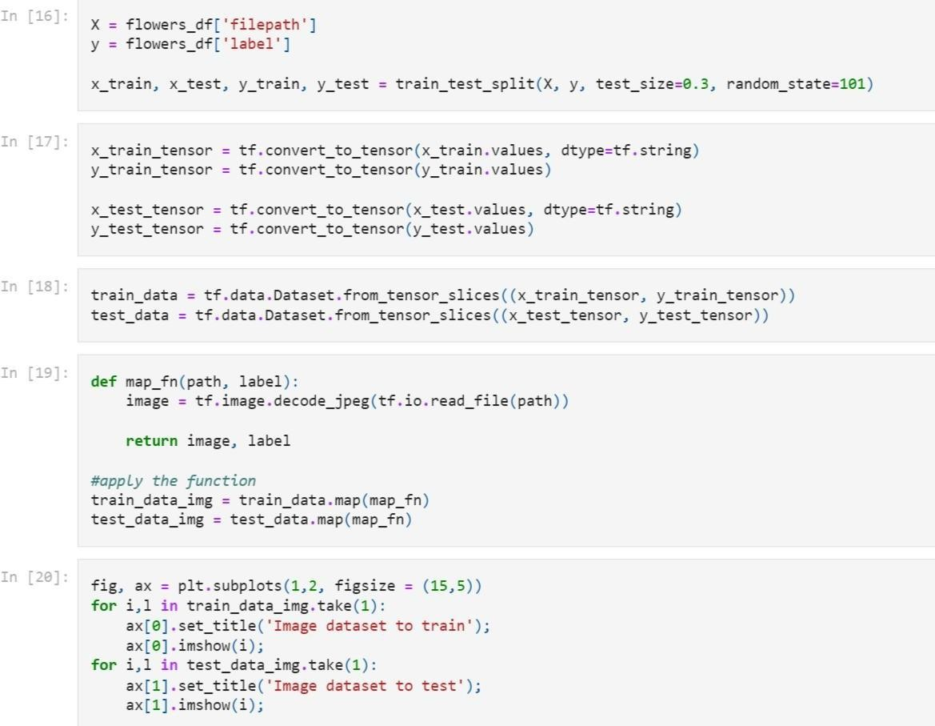

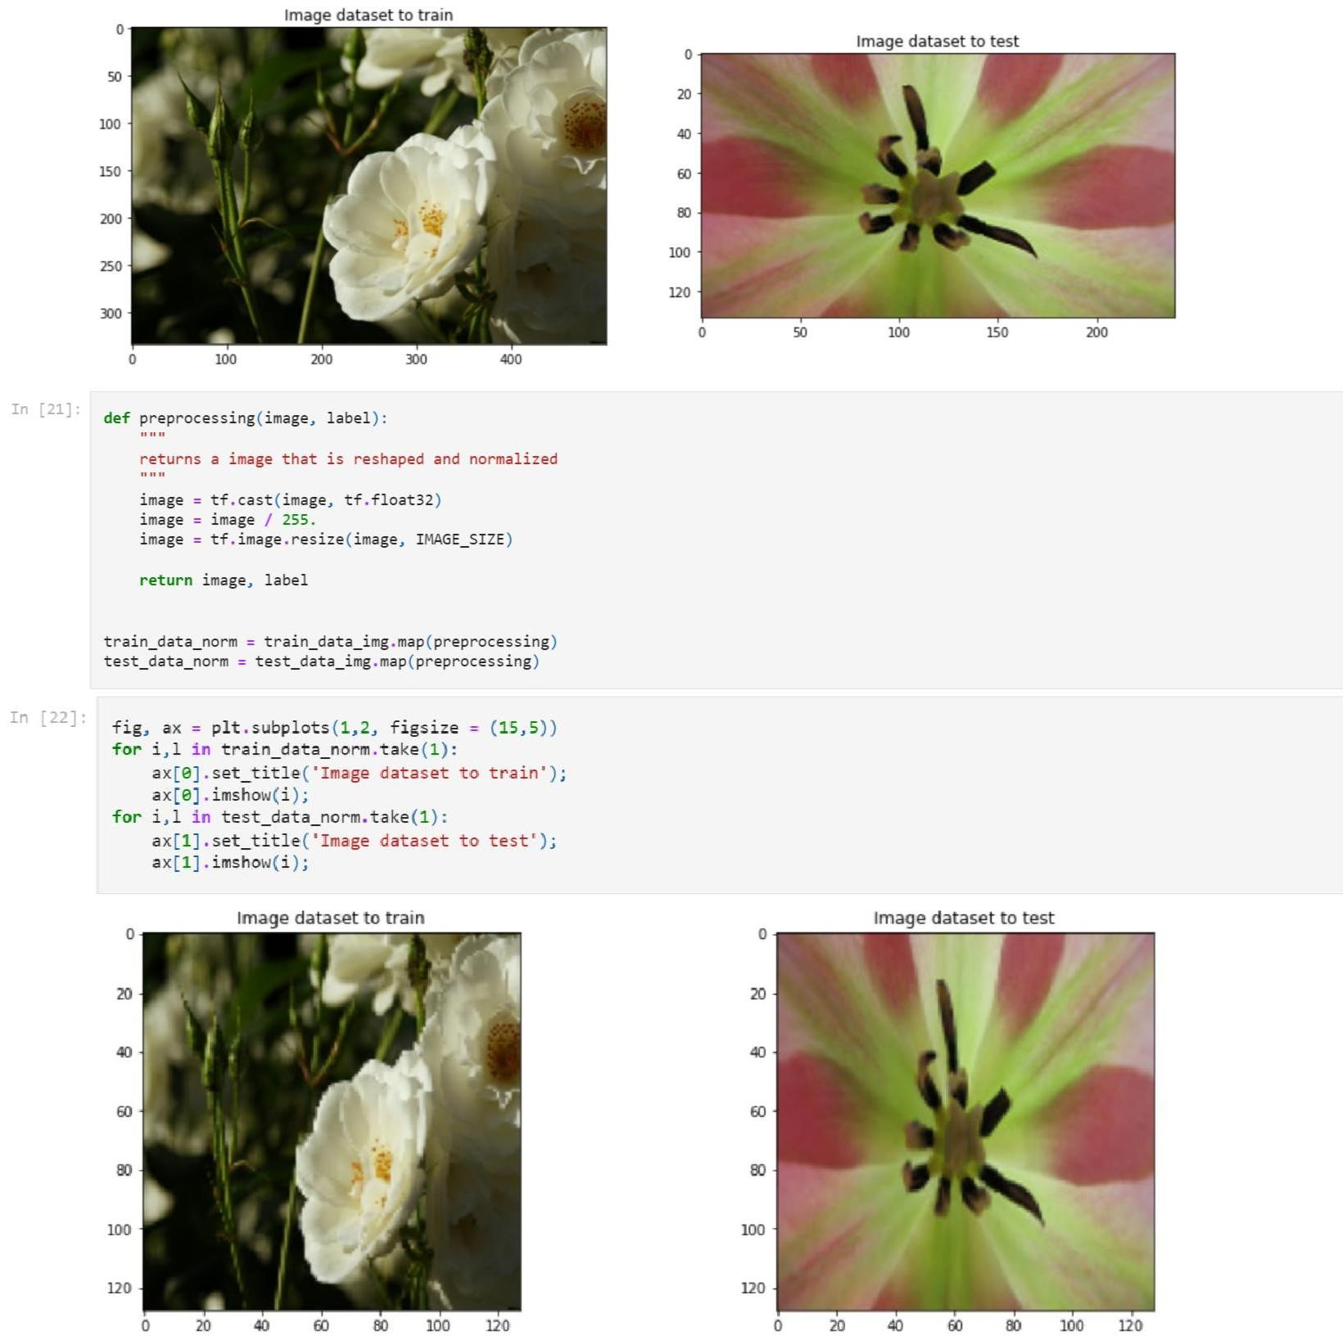

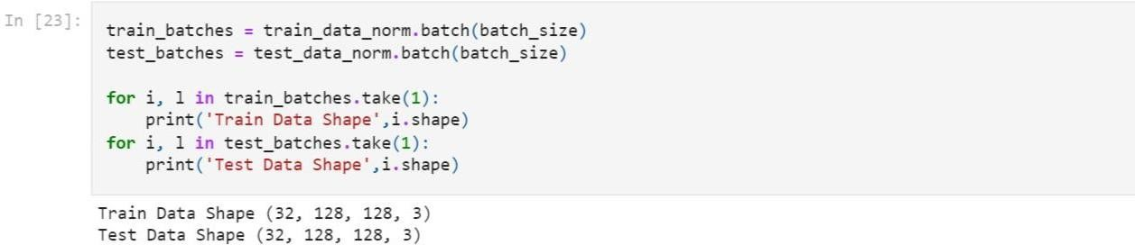

**Question-4 :**

## Add Layers (Convolution,MaxPooling,Flatten,Dense-(Hidden Layers),Output)

Solution :

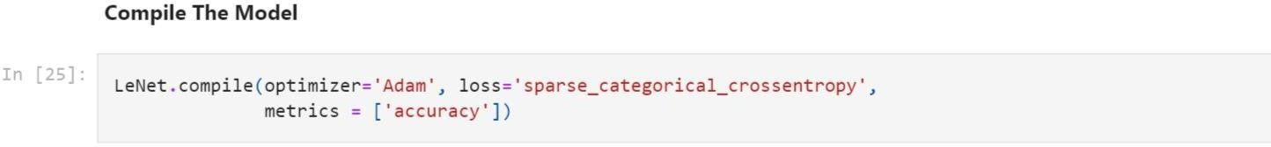

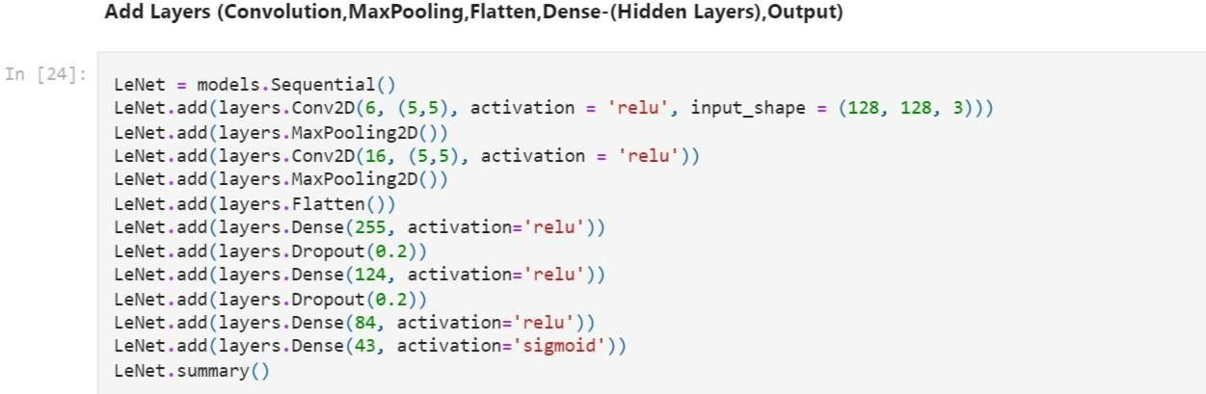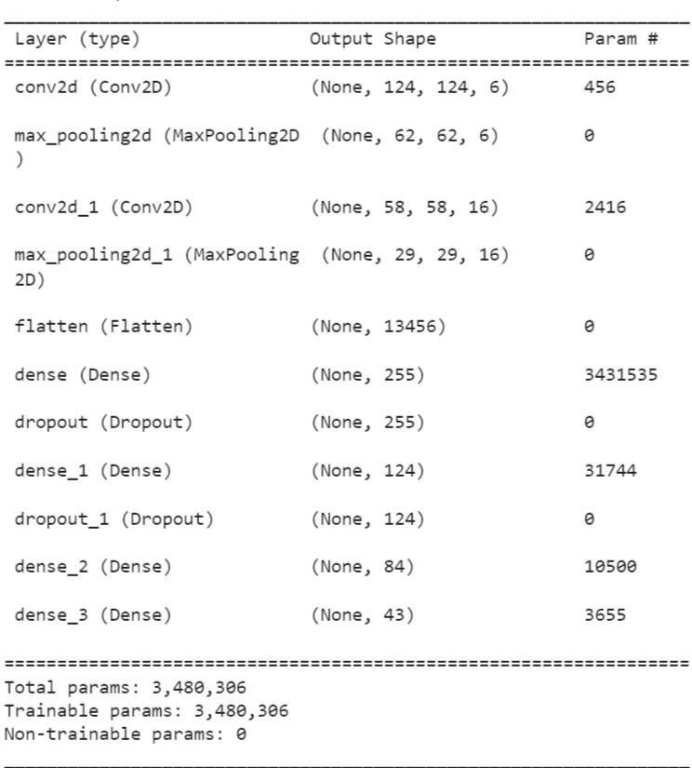

**Question-5:**

**Compile The Model**

Solution :

**Question-6:**

**Fit The Model**

Solution :

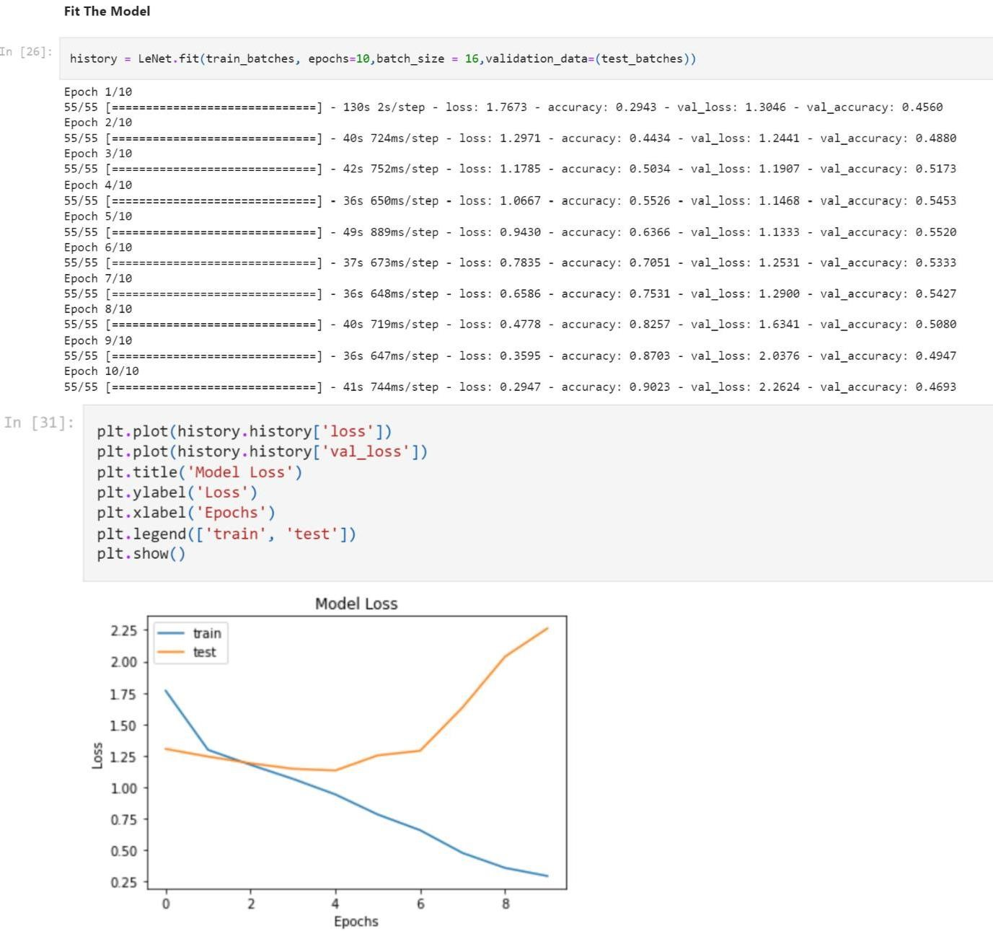

**Question-7:**

**Save the Model**

Solution :

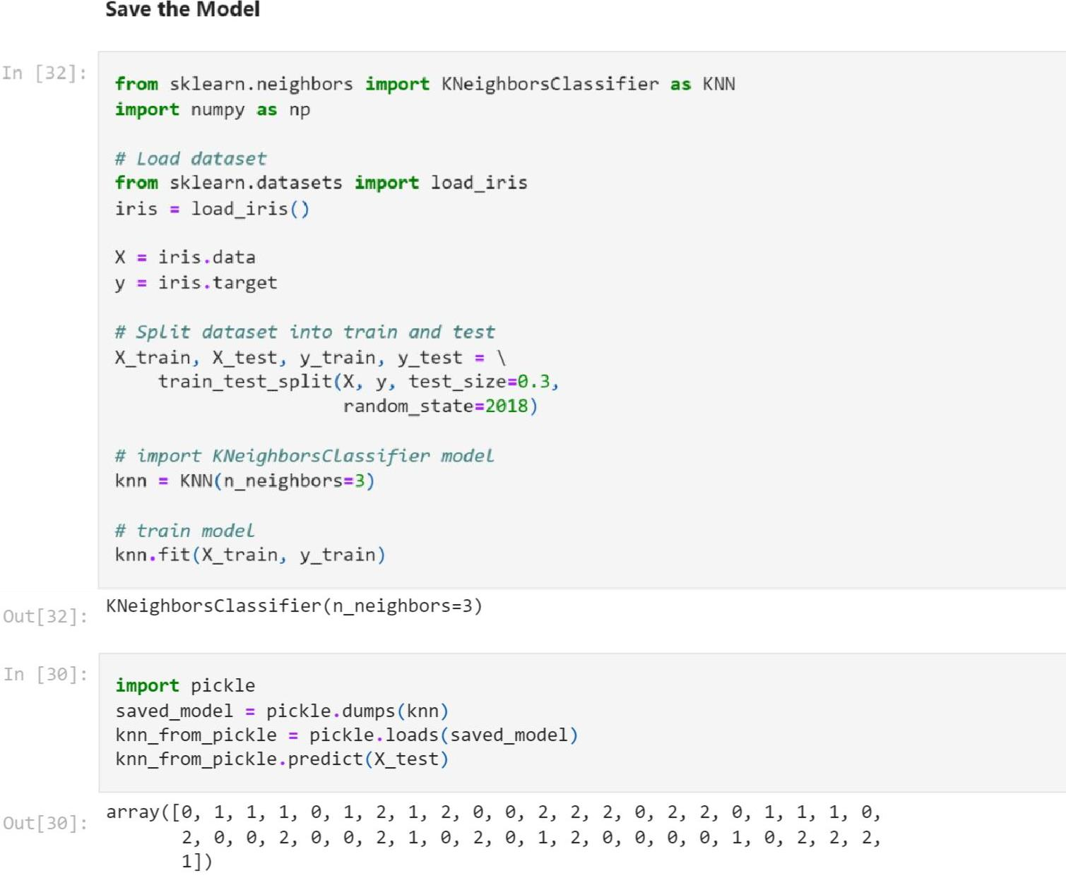

**Question-8:**

## Test The Model

Solution :

